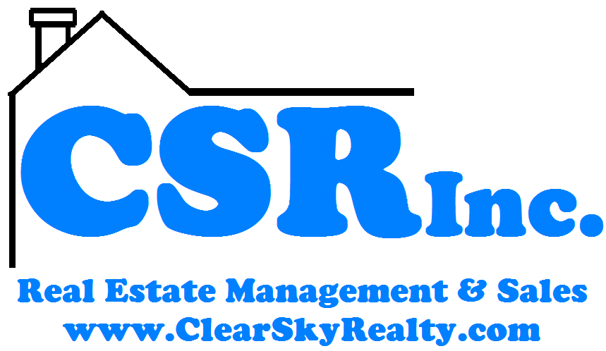

3001 W. Tuscarawas St.
Canton, OH 44708
330-455-4663 x101

Professional Property Management
We offer our knowledge and experience to help you manage your properties!

*Not happy with the results your current management company is getting?
*Tired of dealing with tenants?
*Stressed out about trying to complete a renovation?
*Thinking of selling your rental property?
LET US DO THIS FOR YOU!
We offer a wide range of management opportunities:
- We will lease your property for you and then manage the property after it is leased.
- We have significant experience with repositioning apartment complexes, filling vacancies caused by inattentive management and also maintaining high levels of paying occupants. WE DO NOT GET PAID UNLESS THE TENANTS PAY YOU!
- We handle all rehab and turn-overs for you prior to leasing and in between tenants.
- We will help you buy an investment property or help you sell your investment property.
About Us:
Our management team has owned & managed rental property since 2003. We set up systems and standards that benefit both the owners and the residents. Our management team has a long history of providing BOTH quality homes to residents and good returns to investors. We opened a new real estate brokerage in 2010 so we could bring our management & sales experience to you! In 2012 we opened up a branch office in Columbus Ohio.
Our main office is located at 3001 W. Tuscarawas St, Canton, OH. For information about buying or selling a home please visit: www.ClearSkyRealty.com
Our mission for management is to help you profit from your real estate investing. We do this by decreasing your stress and hassle and by increasing your cash flow. You can learn more by visiting: www.ClearSkyProp.com
Rehab Help for Our Management Clients
- Do you own a property that needs renovation?
- Are you tired of searching for good contractors?
- Would you like someone else to make sure that the work is done in a timely fashion?
WE CAN HELP!
Benefits to having us manage a rehab project for you:
* We get estimates from contractors
* We verify that the work is being done
* We make sure that work is completed in a timely fashion
* By buying in bulk we get many discounts on materials.
WE TAKE THE EFFORT OUT OF A REHAB FOR YOU!
* If we don’t rent your property, we don’t get paid!
* We take the hassle out of tenants, property renovation & repairs, inspections, accounting & bookkeeping for you.
All you should do is review your monthly statement & cash your checks (auto deposit is available if this is too much work.)
*With the hundreds of units we manage, we know what the market is doing & we use this knowledge to benefit you.
When you choose our company, you can relax knowing that your properties are managed by a licensed real estate broker, agents & certified professional housing providers.

We reserve the right to turn down the management of any property or anyone at anytime.
Do you have enough time with your family?
Ask my mom how you can have more.

330-455-4663 x101
- Do you want a higher occupancy rate and less evictions?
- Do you wish someone else would deal with the maintenance issues and communicate with the tenants?

WE CAN HELP!

Benefits to having us Manage for you:
* We build a webpage to advertise your property on our web site: www.ClearSkyProp.com
*We average over 1000 page views per DAY on our web site. AT NO COST TO YOU!
* We show your properties and fill your vacancies for you
* We take all tenant phone calls & work with the tenants so you don’t have to.
* We have a thorough screening process with nationwide criminal and statewide evictions checks. All applicants must pass 25 different checks before they move in
* If you allow pets, we use our time tested & court tested systems to screen pets & increase your income
* WE DO NOT CHARGE A MINIMUM MONTHLY FEE FOR A VACANT UNIT! If you don’t get paid, we don’t get paid!
* Our pay is based on your income and we have many ways to increase the amount of rent collected from every one of your units.
* We itemize all expenses.
* We provide monthly profit and loss statements to aid in filing your taxes.
For more information on management, please visit www.ClearSkyProp.com/owner

Selling Your Property
- Thinking of selling a property?
- You can list your property with us OR you have the option to sell the property on your own
- Many other management companies charge you a commission even if you sell your own property while they manage it. We don’t!

For more information go to:
www.ClearSkyProp.com/owner

*See Management Agreement for full details.

